

**Placement Empowerment Program**

***Cloud Computing and DevOps Centre***

**Set Up a Cloud-Based Monitoring Service:** Enable basic cloud monitoring (e.g., CloudWatch on AWS). View metrics like CPU usage and disk I/O for your cloud VM.

**Name: Sri Pooja K A Department : CSE**

**Introduction**

Cloud-based monitoring services are essential for managing the performance and health of virtual machines and applications in a cloud environment. Tools like Amazon CloudWatch enable you to monitor metrics such as CPU usage, disk I/O, and network traffic. By enabling these services, you can gain insights into system performance and identify potential bottlenecks or failures before they impact your operations.

**Objectives**

* Learn how to enable basic cloud monitoring services for a virtual machine.
* Understand how to view and interpret key performance metrics, including CPU usage and disk I/O.
* Analyze system performance using the monitoring dashboard in the cloud console.

**Step by Step Overview**

**1. Enable Monitoring for Your Virtual Machine:**

* Log in to your AWS management console.
* Navigate to EC2 section.
* Select the instance you want to monitor.
* Go to the "Monitoring" tab of the instance and enable detailed monitoring (if not already enable.
* Save the changes to ensure monitoring is activated.

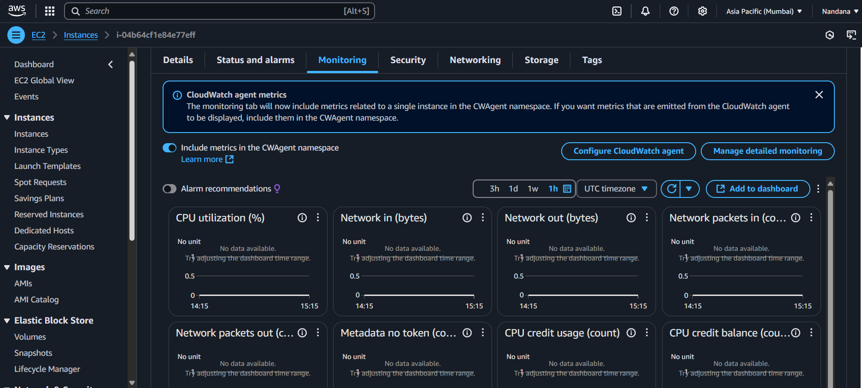

**2. View Metrics in the Monitoring Dashboard**

Open the monitoring dashboard in the aws console.

* Navigate to the Amazon CloudWatch dashboard.
* Select the instance you wish to monitor.
* View real-time and historical metrics such as: CPU Utilization, Disk I/O, Network Traffic.
* Use the graphical interface to customize charts or add widgets for frequently monitored metrics.

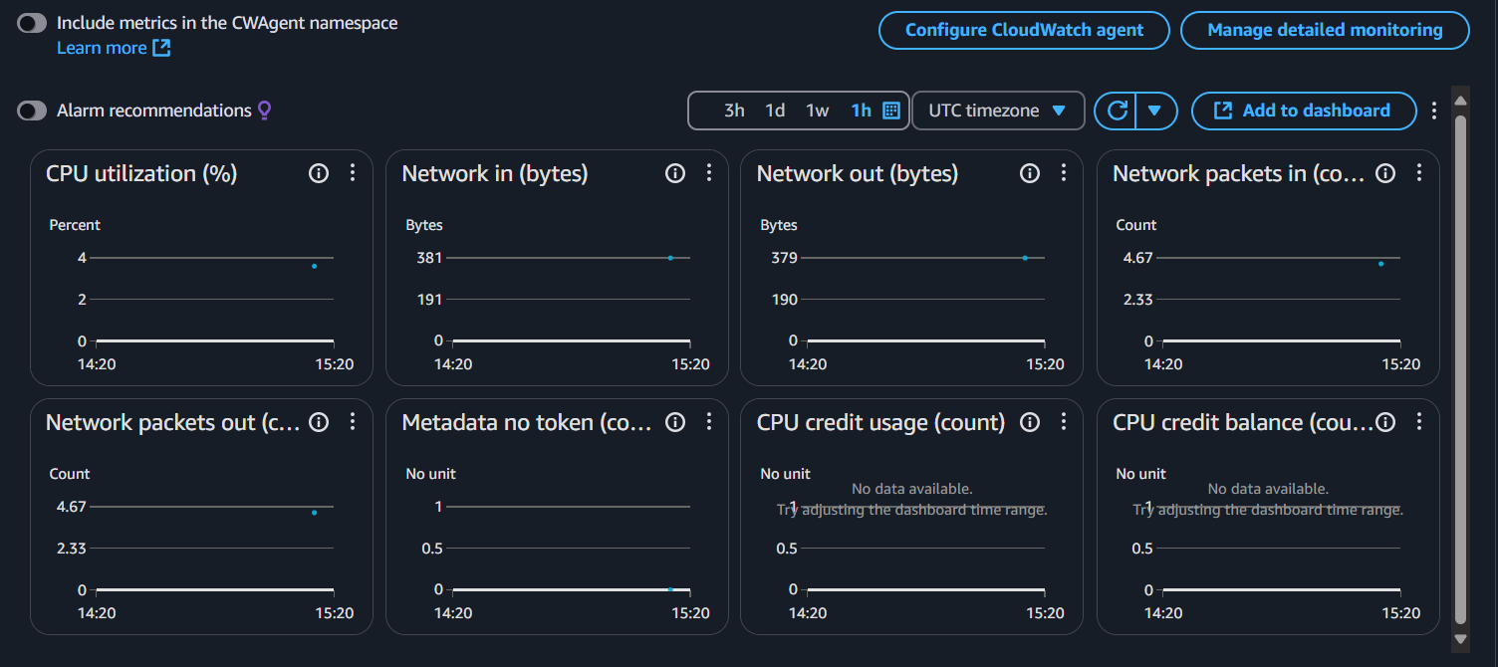

### **3. Set Up Alarms**

### In the monitoring dashboard, locate the "Alarms" or "Alerts" section.

### Create a new alarm. Define the metric to monitor (e.g., CPU utilization above 80%). Set the threshold value and duration to trigger the alarm.

### create an SNS (Simple Notification Service) topic and subscribe to it.

### Save and activate the alarm.

**4. Analyze Performance Trends**

* Review collected metrics over time to identify trends or anomalies.
* Export logs or reports for deeper analysis

**Outcome:**

With this PoC, we learnt about the basics of enabling and using cloud-based monitoring tools. And how to interpret performance metrics like CPU usage and disk I/O. Proactive system performance analysis to ensure operational efficiency. Setting up alerts for critical conditions to minimize downtime.